Practice Quiz on Robotics

1. Kinematics is a branch of mathematics concerned with the

a. position or angles of bodies

b. velocities (rotation or angular) of bodies

c. forces and moments acting on bodies

1. Using Denavit-Hartenberg notation, the relationship between 3D coordinate frames attached to two successive links is described by:

a. 3 parameters

b. 4 parameters

c. 6 parameters

1. For a robot with N joints the links are numbered:

a. from 1 to N

b. from 1 to N+1

c. from 0 to N

1. Link 0 is the:

a. fixed base of the robot

b. end-effector of the robot

1. For a revolute joint the Denavit-Hartenberg parameter:

a. θ is the joint coordinate

b. d is the joint coordinate

1. For a prismatic joint the Denavit-Hartenberg parameter:

a. θ is the joint coordinate

b. d is the joint coordinate

1. The forward kinematics can be expressed as a function of joint configuration and link parameters.

a. True

b. False

1. For a planar robot with just one joint we can:

a. move the end effector to any coordinate (within reach)

b. move the end effector to any coordinate (within reach) and any orientation

c. only move the end effector to any point lying on a circle

1. Using the notation from the figure above the pose of the end effector is given by:

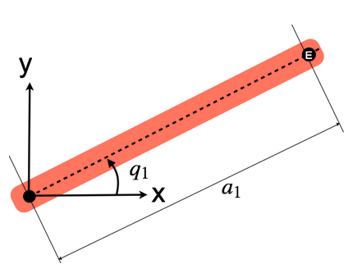

a. R(q1)Tx(a1)

b. Tx(a1)R(q1)

1. For a planar robot with two joints we can:

a. move the end effector to any coordinate (within reach)

b. move the end effector to any coordinate (within reach) and any orientation

c. only move the end effector to any point lying on a circle

1. The x- and y-coordinates of the end-effector are a function of?

a. the first joint angle only

b. the second joint angle only

c. both joint angles

1. Using the notation from the figure above the pose of the end effector is given by:

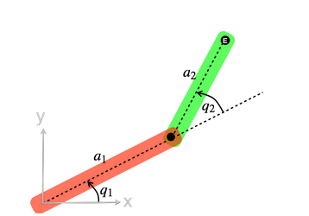

a. Tx(a1)R(q1)Tx(a2)R(q2)

b. R(q1)Tx(a1)R(q2)Tx(a2)

1. In general for planar robot with 2 joints, how many sets of joint angles are there that can result in the same end-effector position?

a. 1

b.2

c.6

d. Infinite

1. Inverse kinematics is concerned with:

a. determining the pose of the robot's end-effector given the joint angles

b. determining the robot's joint angles given the pose of its end-effector

c. the relationship between the velocity of the joints and the rate of change of end-effector pose

1. Velocity kinematics is concerned with:

a. determining the pose of the robot's end-effector given the joint angles

b. determining the robot's joint angles given the pose of its end-effector

c. the relationship between the velocity of the joints and the rate of change of end-effector pose

1. We can compute the velocity of the robot's end-effector by writing the forward kinematics and taking the derivative with respect to time.

a. True

b. False

1. The time derivative of pose is (select all that apply):

a. known as the spatial velocity

b. is denoted by the Greek letter nu, ν

1. For the 2-link planar robot the spatial velocity vector includes rate of change of orientation.

a. True

b. False

1. A Jacobian matrix results from taking the derivative of f(x) with respect to x where f(⋅) is

a. scalar function of a scalar

b. vector function of a scalar

c. scalar function of a vector

d. vector function of a vector

1. If the input to the function is an n-element vector and the result is an m-element vector the Jacobian matrix is:

a. n×n

b.m×m

c. n×m

d.m×n

1. The end-effector spatial velocity is the product of the manipulator Jacobian matrix and the joint velocity vector.

a. True

b. False

1. The manipulator Jacobian matrix is a (select all that apply):

a. constant

b. function of the joint angles and function of the kinematic parameters of the robot

c. function of the kinematic parameters of the robot

d. Function of the joint angles

1. For the 3-link planar robot the spatial velocity vector includes the rate of change of orientation.

a. True

b. False

1. For a 3-link robot we can independently control the magnitude and direction of the end-effector speed.

a. True

b. False

1. The velocity of a point relative to coordinate frame A is related to its velocity relative to frame B by

a. constant transformation

b. Jacobian which is a function of the translation from the origin of frame A to frame B

c.Jacobian which is a function of the rotation from frame A to frame B

d. Jacobian which is a function of the rotation from frame B to frame A

1. In traditional robot manipulators the pose of the end-effector is:

a. measured directly

b. estimated based on measured joint angles and a kinematic model of the arm

c. estimated based on measured joint angles

d. a kinematic model of the arem

1. When using traditional robot manipulators the pose of the object to be grasped:

a. is figured out by the robot

b.must be measured and provided to the robot

1. For a 3D Cartesian task, using a single camera we can control:

a. only 1 of the 3 degrees of freedom

b. only 2 of the 3 degrees of freedom

c. all 3 of the 3 degrees of freedom

1. For a 3D Cartesian task, using a two camera we can control:

a. only 1 of the 3 degrees of freedom

b. only 2 of the 3 degrees of freedom

c. all 3 of the 3 degrees of freedom

1. Visual servoing (select all that apply):

a. involves the use of one or more cameras and to guide a robot or a robot end-effector to perform a task with respect to some object

b. to guide a robot or a robot end-effector to perform a task with respect to some object

c. involves the use of one or more cameras

d. none of the above

1. The image Jacobian relates motion of the camera to motion of a world point on the image plane.

a. True

b.False

1. The image Jacobian for a point is a function of (select all that apply):

a. the focal length of the lens,

b. the coordinates of the point

c. the distance of the object from the camera

d. the focal length of the lens, the coordinates of the point and the distance of the object from the camera